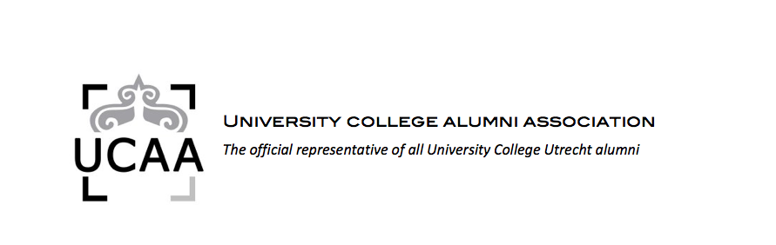**Several alumni were present at UCU’s Career Conference 2011 to answer students’ questions on career paths and provide insight based on their own career experiences. A few of them are briefly introduced below.**

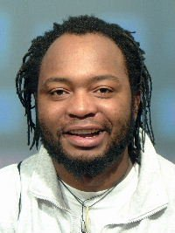

**Bruce Mutsvairo** **(’04)** is a Lecturer in Journalism and Mass Communication at Amsterdam University College. He previously spent four years working as a reporter for the Associated Press Bureau in Amsterdam before embarking on his PhD in International Politics at the University of Hull in England. He holds a MA in International Journalism from Cardiff University. His teaching and research interests include social media, political communication and foreign new reporting.

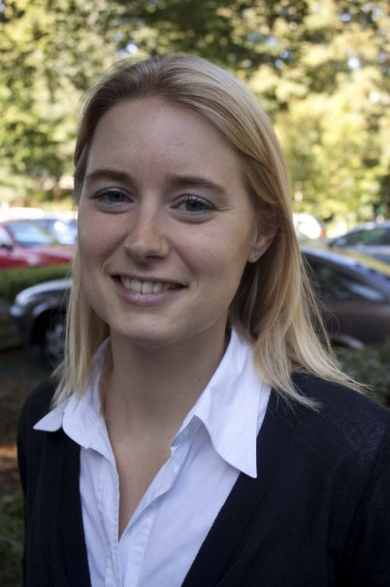**Ariane Kaper (’05)** graduated from UCU with a BSc in Physics, Mathematics and Environmental Sciences. She continued her studies by completing the MSc Energy Science at UU Copernicus Institute. This masters covered topics such as energy technology and energy analysis. Her thesis was about the Greenhouse gas effects of land use changes for palm oil production in Indonesia. Until last year she worked for DHV, an engineering and consultancy firm, and since February she has been employed by Ballast Nedam, a construction company employing 3500 people. She works in the sustainability services department with her tasks ranging from internal consultancy about reducing the carbon footprint of the company, to project management and consultancy, and external product development, such as innovative road concepts and the redevelopment op office buildings.

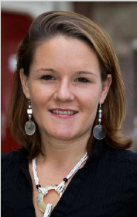

**Claire Stramrood (’03)** graduated from UCU with majors in Psychology and Law and a minor in Medicinal Biology. From here she went on to complete the SUMMA medical programme in Utrecht, which she finished in 2008. Currently she is working on her PhD at Groningen University on ‘Posttraumatic stress in relation to pregnancy and childbirth’. Besides these achievements Claire is also a Physician-teacher, the long-time former chair of the UCAA board and has worked at the Centre for Talented Youth Summer school programme. In this last capacity she taught a class on the Foundations of Psychology to children aged 12-16, developing the curriculum herself and supervising the teaching assistants.

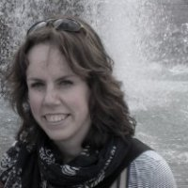

**Linda van Soerland (’09)** graduated from UCU in Political Science and Human Geography. She continued her studies at the London School of Economics, completing an MSc in Regional and Urban Planning Studies. Currently she works as a policy advisor for the governor of Haarlem. Her work consists of advising the provincial government on land use issues, i.e. the often compulsory purchase of land for infrastructure, the implementation of housing projects and nature reserves. She also deals with policy conflicts between her own municipality and the neighbouring areas. She works on the maintenance of the historical structure of the rural landscape and develops new instruments for financing “new nature” which acts to offset the building of new roads.

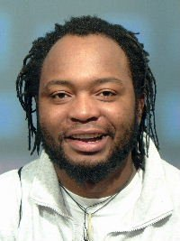

**If you have any questions for these alumni, please contact the UCAA at** [**info@ucaa.nl**](mailto:info@ucaa.nl) **and we will refer you on to the relevant alumnus/alumna. We may even have other suggestions for people you can contact for career information in the alumni community – after all the theme of this years conference was “The Network Society”!**